SIMATS ENGINEERING
ASSESSMENT TOOL 2: Scenario-Based Questions
COURSE NAME: COMPUTER VISION COURSE CODE: ITA05

COURSE OUTCOME COVERED
CO2: Apply image enhancement and segmentation techniques for extracting meaningful regions from images. (BTL 3)

QUESTIONS: 5 Max Marks50 Duration :60 Minutes Annexure A
Scenario-Based Questions

Code of Conduct:
I V. Venkata Susheel Chowdary (192472060) (Name / Reg No) certify that this submission is my original work and that I have adhered to the guidelines specified for this assessment. I understand that any violation of academic
integrity rules will result in disciplinary action.
V. Susheel
Signature of the student:

Annexure A
Scenario-Based Questions

- Dental X-Ray Enhancement and Cavity Region Extraction
A dental clinic uses a digital radiography system to help dentists locate early-stage cavities (caries) in teeth. The X-ray images are dark and low in contrast, with quantum noise and overlapping tooth structures, so small cavity regions blend into the surrounding enamel and dentine.
Question: Apply suitable grey-level transformations (such as negative, log or power-law transformation) and histogram equalization to improve the visibility of the cavity regions. Select an appropriate spatial smoothing filter to suppress noise without blurring the cavity boundaries. Subsequently, apply thresholding or region growing to extract the suspected cavity region, and use edge detection to outline it. Explain the sequence of processing steps and justify the choice of each technique.

Night-Time Vehicle Number Plate Region Extraction
A traffic police department installs CCTV cameras at a toll gate to capture vehicles at night. The images suffer from very low brightness, headlight glare, sensor noise, and motion blur. The system must locate and extract the number-plate region so that the characters can be read in a later stage.
Question: Apply suitable grey-level transformations and histogram processing to enhance the dark regions while controlling glare. Use appropriate smoothing and sharpening filters (for example, median filtering followed by Laplacian or unsharp masking) to reduce noise and restore character edges. Apply edge detection, line detection and edge linking to locate the rectangular plate boundary, and use thresholding to separate the characters from the plate background. Present the complete processing pipeline and explain how each step contributes to extracting the number-plate region.

Textile Fabric Defect Detection Using Frequency-Domain Processing
A textile mill inspects woven fabric rolls using a line-scan camera. The fabric has a regular, repeating weave pattern, and defects such as holes, broken threads, oil stains and knots disturb this pattern. The
captured images also contain periodic noise from the machine lighting and uneven illumination across the width of the roll.
Question: Apply suitable frequency-domain filtering techniques (low-pass, high-pass, or notch/bandreject filtering) to suppress the periodic noise and the regular weave texture, so that the defects stand out. Use
histogram processing to correct the uneven illumination. Subsequently, apply thresholding and boundary detection to segment and outline the defective regions. Explain the order of operations and justify why frequency-domain processing is preferred over spatial-domain processing in this scenario.

Blood Cell Segmentation in Microscopic Images
A pathology laboratory uses an automated microscope to capture images of stained blood smears for counting red and white blood cells. The images show uneven staining, poor contrast between cells and background, touching or overlapping cells, and noise from dust particles on the slide.
Question: Apply suitable contrast enhancement and histogram processing techniques to improve the separation between cells and background. Use an appropriate spatial filter to remove small noise particles while preserving cell boundaries. Apply global or adaptive thresholding to separate cells from the background, and use region-based segmentation (region growing or region splitting and merging) to separate touching cells. Finally, apply edge detection and boundary detection to outline individual cells. Explain the processing sequence and the role of each technique in obtaining accurate cell regions.

Text Extraction from Degraded Historical Documents
A state archive is digitising old handwritten manuscripts. The scanned pages contain yellowed paper, ink bleed-through from the reverse side, stains, faded strokes and uneven lighting across the page. The archive requires clean extraction of text regions before handwriting recognition.
Question: Apply suitable grey-level transformations and histogram processing to improve the contrast between faded ink and the background. Select appropriate smoothing and sharpening filters to remove stains and noise while strengthening the pen strokes. Compare global thresholding (such as Otsu's method) with local (adaptive) thresholding for this scenario and apply the more suitable one to separate text from the background. Use edge detection and boundary detection to identify text lines and word regions. Explain the sequence of operations and justify each decision.

RUBRICS FOR CALCULATION:

Criteria | Weightage | Level 4 (Exemplary) | Level 3 (Proficient) | Level 2 (Developing) | Level 1 (Beginning)
Understanding of Scenario | 20% | Demonstrates clear and complete understanding of the scenario and context | Shows good understanding with minor gaps | Partial understanding;  misses key aspects | Misinterprets or fails to understand the scenario
Identification of Key Issues | 20% | Accurately identifies all relevant issues and factors involved | Identifies most key issues with minor omissions | Identifies limited issues; some irrelevant points | Unable to identify key issues
Application of Concepts | 25% | Applies appropriate concepts effectively to address the scenario | Applies concepts with minor errors | Limited or partially correct application | Unable to apply relevant concepts
Decision Making | 20% | Makes well-reasoned, logical decisions with strong rationale | Makes reasonable decisions with some justification | Makes weak decisions with limited justification | No clear decisions made or rationale provided
Clarity of Response | 15% | Response is clear, structured, and logically presented | Generally clear with minor issues | Somewhat unclear or poorly  structured | Disorganized and difficult to understand

Digital Image Processing – Scenario-Based Answers

Dental X-Ray Enhancement and Cavity Region Extraction Aim
To enhance low-contrast dental X-ray images, reduce quantum noise, and extract suspected cavity regions while preserving tooth boundaries.

Processing Steps
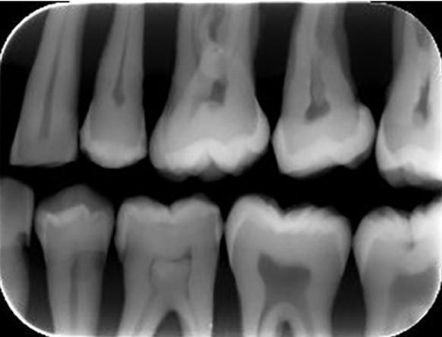

Step 1: Image Acquisition
Load the grayscale dental X-ray image containing dark, low-contrast tooth regions and suspected cavities.
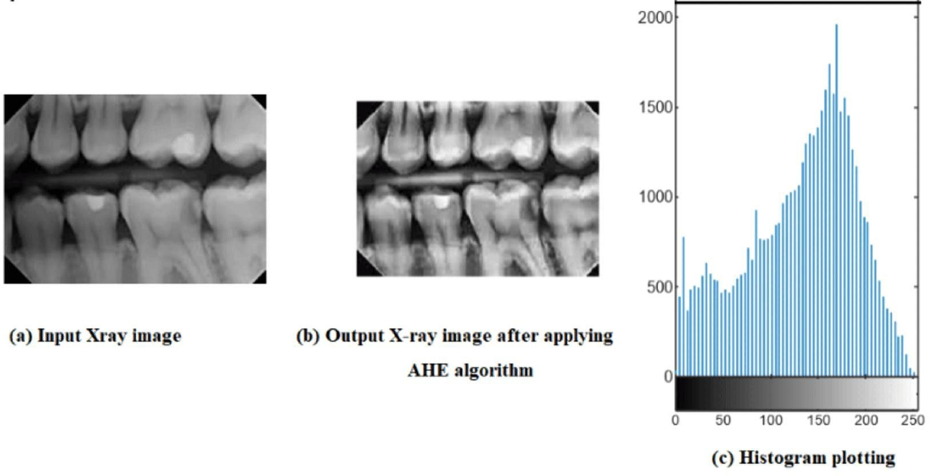

Step 2: Grey-Level and Histogram Enhancement
Apply a logarithmic transformation to improve visibility in darker regions. Use histogram equalization or CLAHE to enhance local contrast between enamel, dentine, and suspected cavities.

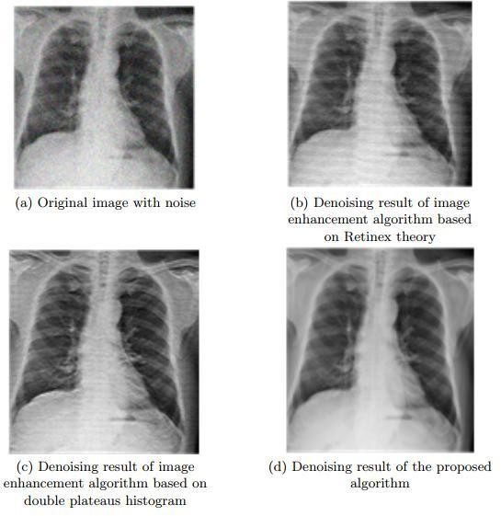

Step 3: Noise Removal
Apply a median filter or a small bilateral filter to suppress noise while preserving important cavity boundaries.
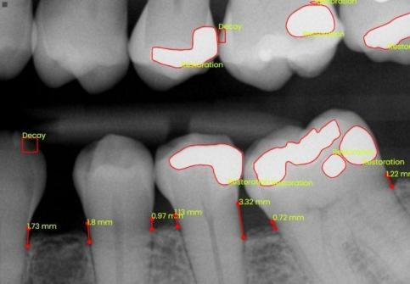

Step 4: Cavity Segmentation

Use adaptive thresholding or region growing to identify suspicious low-intensity regions. Apply Canny edge detection to outline their boundaries.
Justification of Techniques
- Log transformation: Expands the visibility of darker intensity values.
- CLAHE: Improves local contrast without excessively enhancing the entire image.
- Median or bilateral filter: Reduces noise while protecting sharp transitions.
- Adaptive thresholding: Handles local brightness variations better than a single global threshold.
- Canny edge detection: Identifies boundaries around candidate cavity regions.
Expected result: An enhanced dental X-ray with suspected cavity regions segmented and outlined for further examination by a dentist. Image processing alone cannot confirm a diagnosis.

Night-Time Vehicle Number Plate Region Extraction Aim
To improve night-time vehicle images and locate the rectangular number-plate region despite low brightness, headlight glare, noise, and motion blur.

Processing Pipeline
- Input Image
Capture the night-time vehicle image.
- Brightness and Contrast Enhancement
Use gamma correction and CLAHE to reveal dark plate regions.
- Noise Reduction
Apply median filtering to suppress impulse noise.
- Sharpening
Use unsharp masking to enhance character edges; use Laplacian sharpening cautiously.
- Edge and Line Detection
Apply Canny edge detection and Hough line detection to identify plate boundaries.
- Edge Linking and Plate Localization
Join nearby edges and select rectangular regions with plausible aspect ratios.
- Plate Extraction and Binarization
Crop the plate and use adaptive thresholding to separate characters from the background.

Explanation of Techniques
  - Gamma correction: A gamma value below 1 brightens dark image regions. It should be selected carefully because it can also increase glare.
  - CLAHE: Improves local contrast between plate characters and the plate background.
  - Median filtering: Removes isolated noise pixels while preserving edges better than a simple averaging filter.
  - Unsharp masking: Enhances character boundaries. It does not fully recover information lost through severe motion blur.
  - Canny edge detection: Detects strong plate and character edges.
  - Hough line detection: Identifies horizontal and vertical lines that may form a rectangular number plate.
  - Edge linking: Connects fragmented boundary segments to form a more complete plate outline.
  - Adaptive thresholding: Separates characters from the plate background when illumination is uneven.
Controlling glare: Use highlight detection or local contrast processing to prevent bright headlights from dominating enhancement. If glare or motion blur has destroyed image details, additional image information may be required.
Expected result: A cropped, enhanced number-plate image with characters separated from the background, ready for optical character recognition (OCR).

Textile Fabric Defect Detection Using Frequency-Domain Processing Aim
To suppress periodic noise and repetitive weave texture, correct uneven illumination, and identify fabric defects such as holes, broken threads, knots, and stains.

Processing Steps
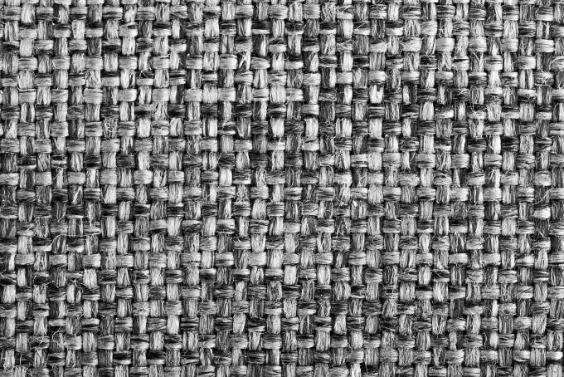

Step 1: Image Acquisition

Capture the fabric image and convert it to grayscale. Inspect the image for periodic patterns and uneven brightness.
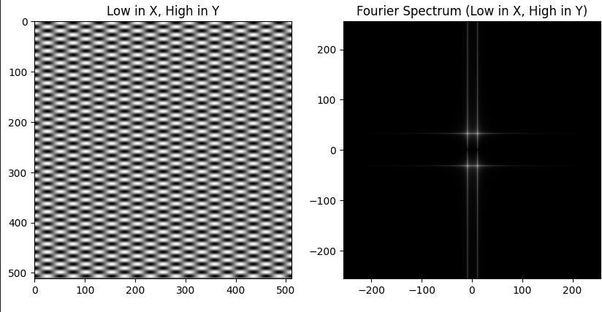

Step 2: Fourier Transform
Apply the 2D Fast Fourier Transform (FFT) to convert the image into the frequency domain. Regular weave patterns and periodic lighting noise may appear as identifiable frequency peaks.

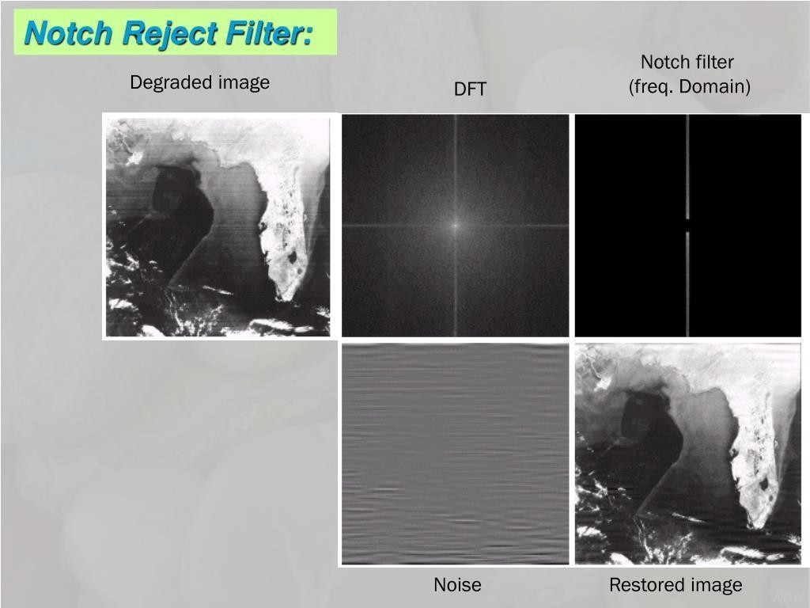

Step 3: Frequency-Domain Filtering
Apply notch-reject filters to remove specific periodic noise frequencies. Use a carefully designed band-reject or high-pass filter when appropriate to suppress selected texture frequencies.

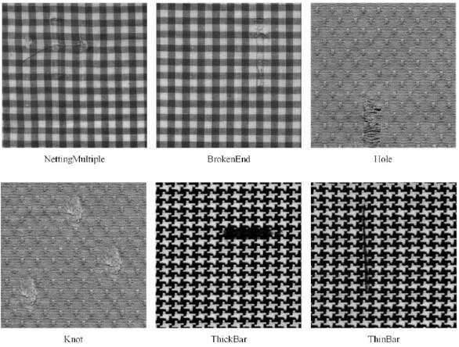

Step 4: Inverse Transform and Illumination Correction
Apply the inverse FFT to reconstruct the filtered image. Correct slow illumination variations using background estimation and suitable histogram normalization.

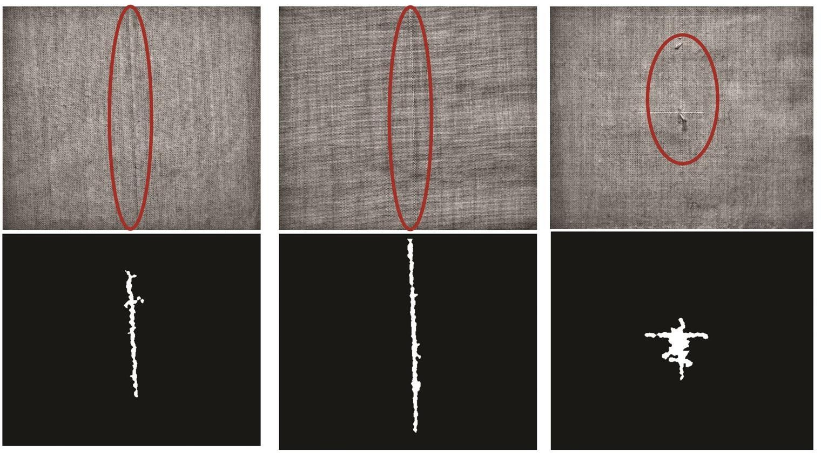

Step 5: Defect Segmentation
Apply thresholding, morphological operations, and boundary detection to identify and outline abnormal regions.
Justification of Techniques
- FFT: Separates image information according to spatial frequency.
- Notch-reject filtering: Removes narrow, identifiable periodic noise components.
- Band-reject filtering: Suppresses a selected range of frequencies when the unwanted texture occupies that range.
- High-pass filtering: Highlights fine details, but may amplify noise.
- Histogram processing and background correction: Improve visibility across regions with different illumination levels.
- Thresholding and boundary detection: Separate suspicious defects from the surrounding fabric.

Why is frequency-domain processing preferred?
The fabric contains regular, repeating patterns and periodic machine noise. These unwanted components often create distinct frequency peaks, which can be selectively suppressed in the frequency domain. A spatial filter may blur both the weave and the defects, making small holes or broken threads harder to detect.
However, the weave and defects may overlap in frequency. Therefore, filtering must be carefully designed to avoid removing genuine defects.

Expected result: A fabric image with reduced periodic interference and highlighted defect regions suitable for automated quality inspection.

Blood Cell Segmentation in Microscopic Images Aim
To enhance microscopic blood-smear images, remove small noise particles, separate touching blood cells, and outline individual cells for counting.

Processing Pipeline
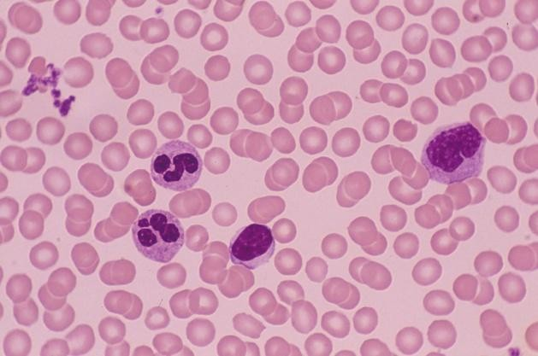

Step 1: Image Acquisition
Load the stained blood-smear image and identify the cells and background.
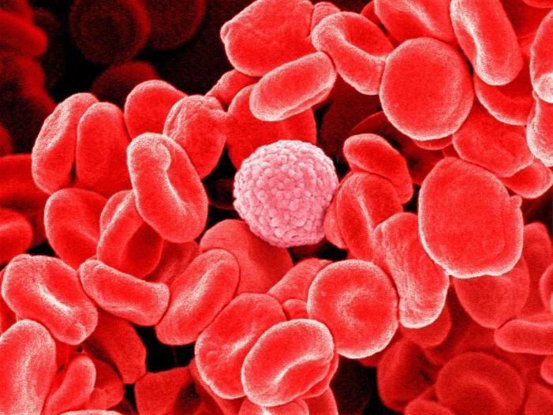

Step 2: Contrast Enhancement
Apply histogram equalization or CLAHE to improve cell-background contrast. If needed, separate colour channels or convert the image to an appropriate colour space.

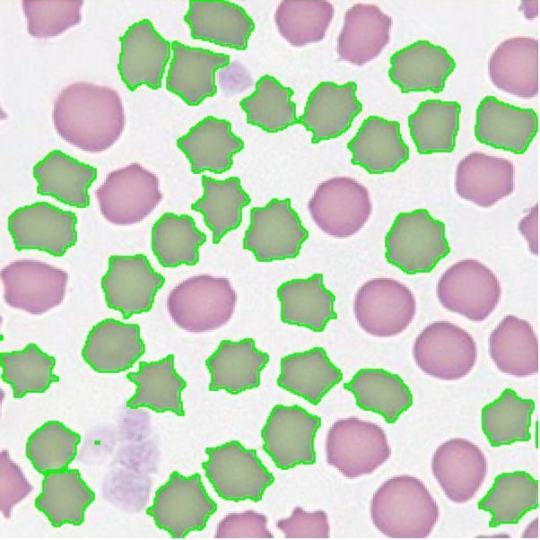

Step 3: Noise Removal
Apply a median or bilateral filter to remove small dust particles while preserving cell boundaries.
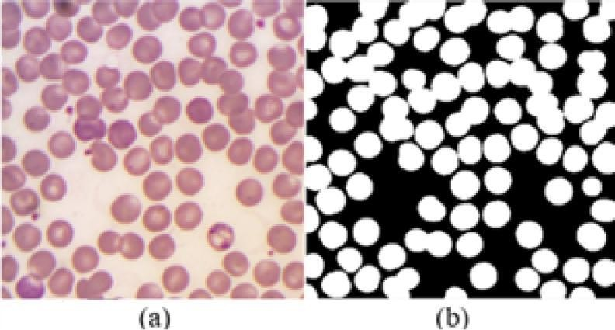

Step 4: Thresholding and Region Segmentation
Use adaptive thresholding when staining or illumination varies. Apply connected-component analysis and watershed segmentation, optionally guided by a distance transform, to separate touching cells.

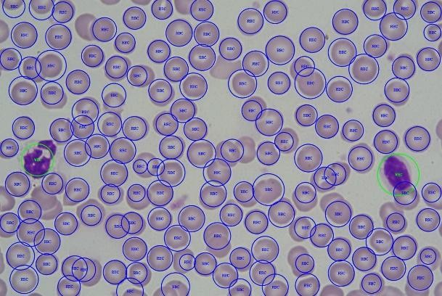

Step 5: Edge and Boundary Detection
Apply Canny edge detection or morphological boundary extraction to outline the segmented cells and measure their regions.
Justification of Techniques
- CLAHE: Improves local contrast despite uneven staining.
- Median or bilateral filter: Removes noise without excessive boundary blurring.
- Adaptive thresholding: Handles varying background intensity and staining conditions.
- Region growing: Groups connected pixels with similar intensity or colour.
- Watershed segmentation: Separates touching cells by identifying boundaries between neighbouring regions.
- Boundary detection: Produces cell outlines for counting and shape measurement.
Expected result: Individual cell regions are segmented and outlined, supporting red and white blood cell counting. Accuracy depends on stain quality, image resolution, and how well touching cells can be separated.

Text Extraction from Degraded Historical Documents Aim
To enhance faded handwriting in historical manuscripts, reduce paper stains and bleed-through, separate text from the background, and extract text-line and word regions.

Processing Steps

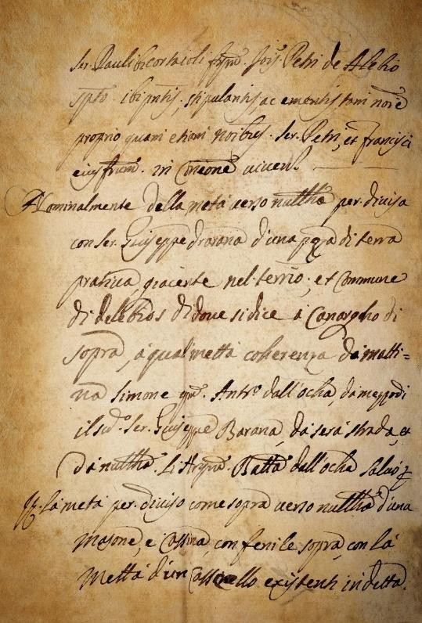

Step 1: Image Acquisition and Grayscale Conversion
Load the scanned manuscript and convert it to grayscale or an appropriate colour space for paper and ink separation.

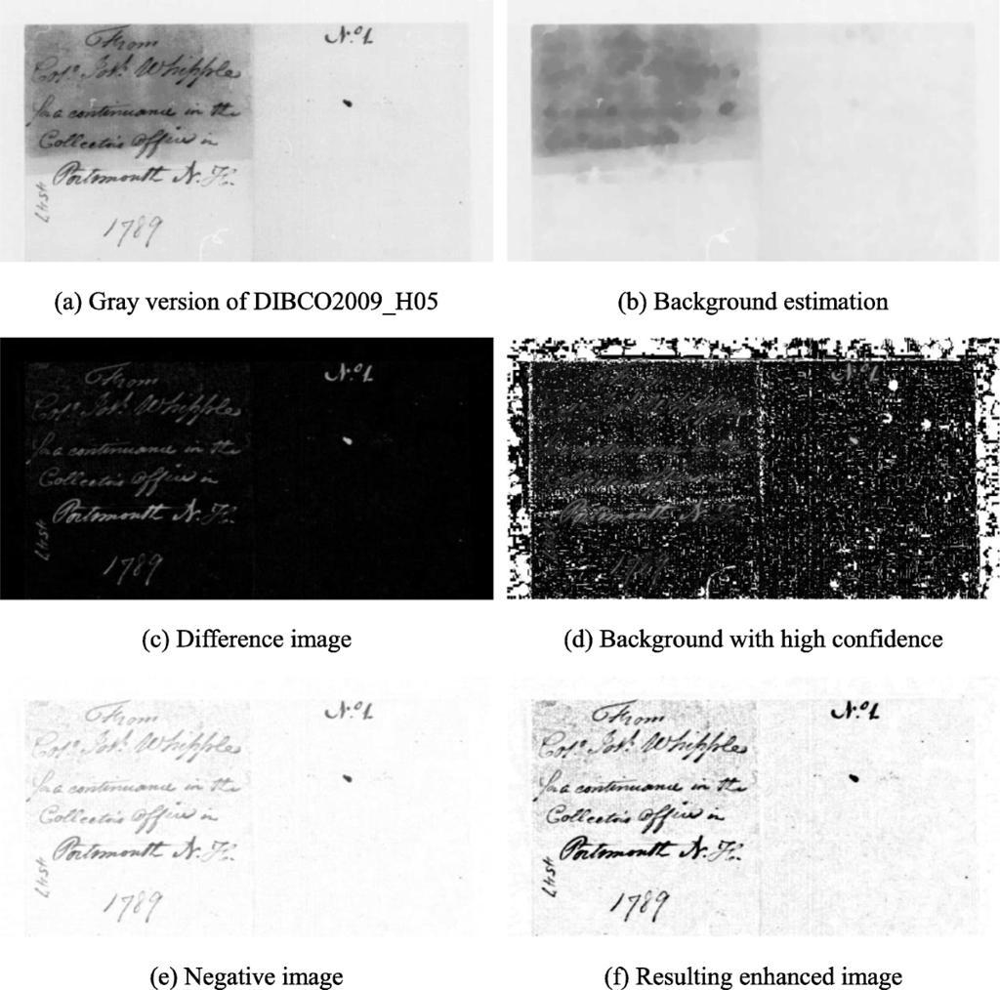

Step 2: Grey-Level and Histogram Enhancement
Apply gamma correction or a power-law transformation to reveal faint strokes. Use CLAHE to improve local contrast and background estimation to compensate for uneven illumination.

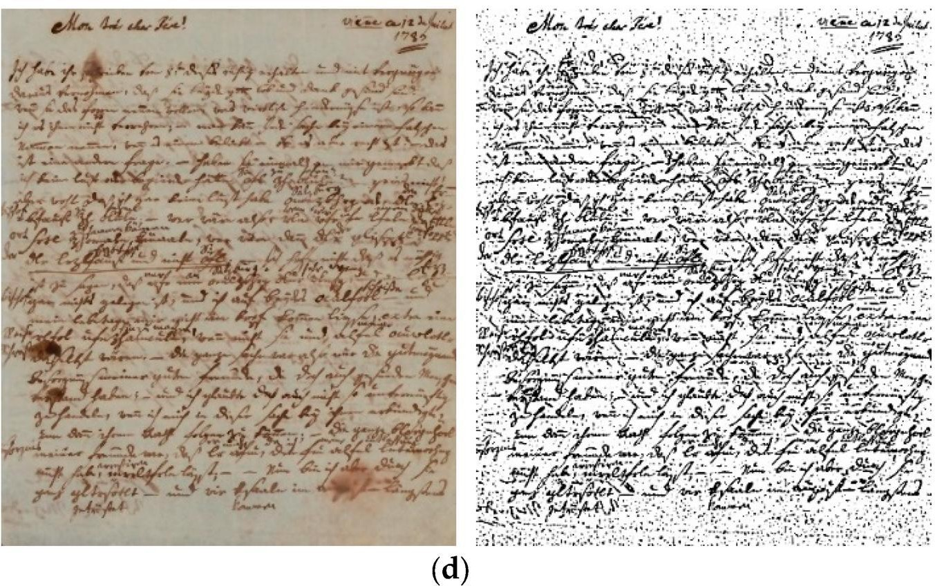

Step 3: Noise Removal and Sharpening
Use a small median filter to remove isolated noise. Apply mild unsharp masking to strengthen faded pen strokes without amplifying stains or ink bleed-through.

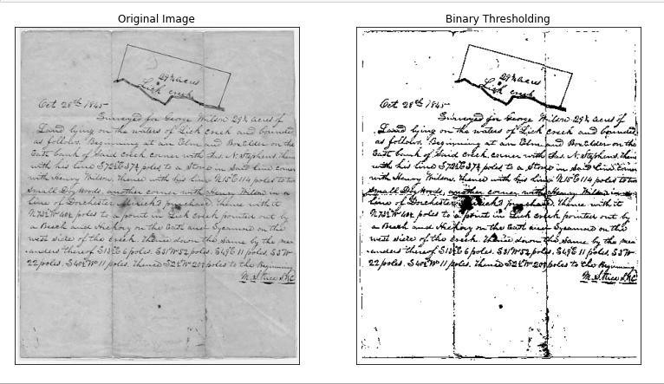

Step 4: Thresholding
Apply adaptive thresholding to separate ink from paper because illumination and paper colour vary across the page.
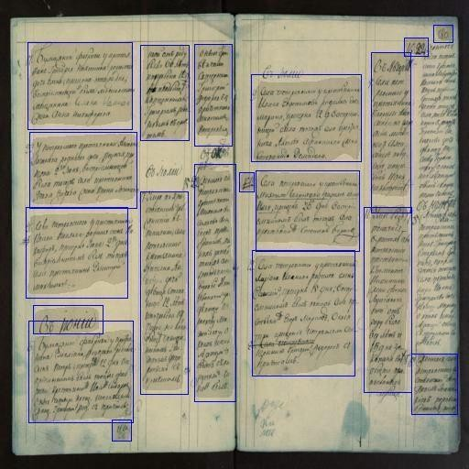

Step 5: Text Region Extraction
Use morphological operations, connected-component analysis, and boundary detection to locate text lines and word regions before handwriting recognition.

Global Thresholding vs. Local Adaptive Thresholding

Feature | Global thresholding (Otsu's method) | Local adaptive thresholding
Threshold | One threshold for the entire image | Threshold calculated for local neighbourhoods
Best suited for | Uniform background and illumination | Uneven lighting, stains, and faded strokes
Advantages | Simple, fast, and automatic | Handles local intensity variations
Limitations | May miss faded ink or retain dark stains | Can amplify local noise if parameters are poorly selected
Suitability | Less suitable for strongly degraded pages | Preferred for this scenario

Justification of Techniques
- Gamma correction: Improves the visibility of faint ink strokes.
- CLAHE: Enhances local differences between ink and paper.
- Background estimation: Reduces the effect of yellowed paper and uneven illumination.
- Median filtering: Removes isolated noise while preserving many stroke boundaries.
- Unsharp masking: Strengthens text strokes when applied moderately.
- Adaptive thresholding: Separates handwriting from a nonuniform background more effectively than a single global threshold.
- Morphological processing and connected components: Help group ink pixels into text lines and word regions.
- Boundary detection: Identifies the outer limits of the extracted text regions.
Expected result: A cleaner binary manuscript image with text-line and word regions identified, ready for handwriting recognition (HTR).

Overall Comparison of the Five Scenarios

Scenario | Main enhancement | Noise reduction | Segmentation | Boundary detection
Dental X-ray | Log transformation and CLAHE | Median/bilateral filter | Adaptive  thresholding or region growing | Canny
Number plate | Gamma correction and CLAHE | Median filter | Plate localization and adaptive thresholding | Canny and Hough lines
Textile defects | Histogram  correction and FFT filtering | Notch/band-reject filter | Thresholding and morphology | Morphological boundaries
Blood cells | CLAHE and histogram  enhancement | Median/bilateral filter | Adaptive  thresholding and watershed | Canny or  morphological boundaries
Historical documents | Gamma correction and CLAHE | Median filter and mild sharpening | Adaptive thresholding | Connected  components and boundaries

Conclusion
Digital image processing techniques must be selected according to the characteristics of the image and the objective of the application. Grey-level transformations and histogram processing improve contrast, while spatial filters reduce noise and preserve important details. Frequency-domain filtering is particularly effective for periodic noise in textile images, whereas adaptive thresholding is useful for images with uneven illumination, such as historical manuscripts and night-time number plates. Finally, segmentation, edge detection, and boundary detection help extract the required regions for further analysis. The quality of the final result depends on choosing suitable parameters and validating the extracted regions against the original images.

